2.4.2 The Intermediate Value Theorem

Question to the Class: Suppose is a continuous function on the set of real numbers. Suppose you know that and . Must this function have a zero (i.e. an x value such that )?

Note: The key here is to think about what the graph will look like. The next theorem addresses this question.

Theorem (The Intermediate Value Theorem):
Suppose that is continuous on the closed interval and let N be any number between and where . Then, there exists a number c in such that .

Proof: The proof is beyond the scope of this course and is not included in the text, but the picture below illustrates the idea.
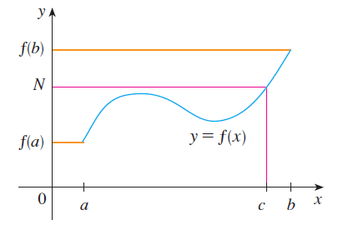

Example 1: Suppose that Bob and Alice each take a 9 hour trip (during the same time interval). The temperature that Bob is experiencing at time t (in hours) is given by the continuous function . Similarly, the temperature for Alice is given by the continuous function (both functions are continuous on ). Suppose that you are told and . Prove there is a time c such that .

Let . By a theorem from the previous section is continuous on .
Moreover, we know that and . By the intermediate value theorem there must exist a such that .
This implies that as desired.

Note: This solves one of the intro problems from the first day of class!

Example 2: Show that there is a root (i.e. solution) to the equation: .

We consider the function which we know is continuous for all real numbers.
We note that and .
By the intermediate value theorem there must exist a such that .
This immediately implies that the equation has a root (In fact, we have proven there is a root between 0 and 2).

Note: Really, for the above example we just need one value of x that produces a negative range value and one value of x that produces a positive range value. So, many proofs are possible.

Example 3: Show that the graph of function obtains a y-value of at least once.

Since and are continuous for all real numbers, we know that f is continuous because f is the difference of these two functions.
We note that and

By the intermediate value theorem there must exist a such that .
This immediately implies that the function obtains a y-value of at least once in the interval .

